Using the Aplia software in the Accounting class
Accounting in a Digital World
Michelle Bruna, USD 108 and LB Wacker, Cengage Learning

Contents
Using the Aplia software as a Student 2
Student Screen 2
Time to Work! 3
Posting—how do those assignments look? 3
Study guide 3
Discussion 4
Put on Your Teacher Hat 4
Course Outline 5
Where are the Tests? 6
Moving a large amount of assignments 7
Discussion 7
Gradebook 7
Announcements 7
Writing Your Own Questions 7
Administration 8
Extending a Due Date 8
Videos 9
Appendix A 10

Accounting in the Digital Age
  - Michelle Bruna, USD 108 and LB Wacker, Cengage Learning

Using the Aplia software as a Student
As a teacher, I hand out the directions to the students in order for them to enter into the class and “pay.” This is the first thing you must do in class with the students and can take 5-15 minutes depending on if the kids are logged into their computer and your internet speed. When you buy access to Aplia, you receive a “booklet” with the instructions and the payment code.

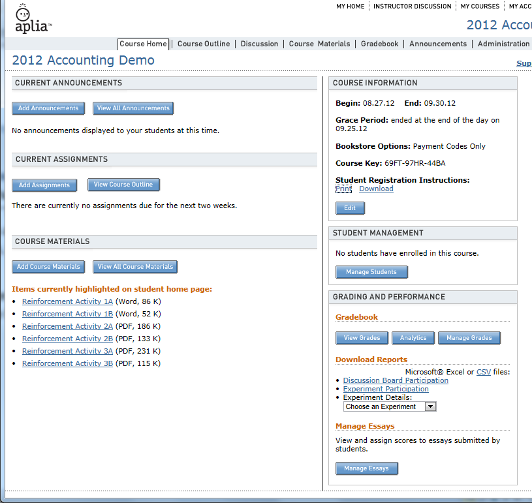

Student Screen
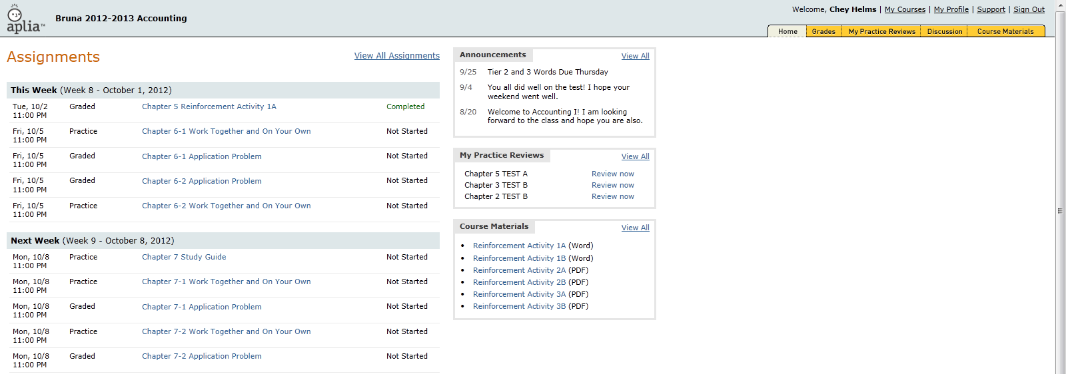
Below is a snapshot of a typical student screen. It tells the student what assignments are due this week and the next week. It also tells them what assignments are for practice, which assignments are graded and lets them know if they have completed the assignment. You as the teacher can add announcements.

Time to Work!
To get students acquainted with Aplia, there is an Introduction to Aplia assignment.
- Under your Assignments listing, Week 1, select Introduction to Using Aplia. On the next screen you will see 5 parts. Look to the right of the assignment and notice the points assigned to each section. Take a few minutes and complete the five sections.

Now that you feel comfortable on how to enter information, we will do some choice problems.

While being a teacher, you can show your screen and work the problems with the students. Watch my screen as we do these problems.

One of the great things about Aplia is that the directions to any problem are on the screen. Textbook left in locker? No worry, just open the problem on the screen.

- Click on Chapter 3-1 Work Together and On Your Own
- Click on Introduction to the OWP Journal
- Now, complete the transactions for the assignment.
- Notice the green Grade button at the bottom of the screen.
- Hopefully, you received green check marks. If you have a red x, you have a mistake and can fix it now.

Study guide
The study guide is listed as a practice assignment. I always change it to be graded. We usually do the study guide the day before the test. We are going to work on the study guide and then I will show you how the students can print it with the correct answers.
- From the assignments screen, click Chapter 3 study guide.
- Complete the Part One-Identifying Accounting Terms portion or more if you are waiting
- Click Save and Continue
Now I am going to change the time the assignment is due. Once I complete that step, you can go back to the study guide and print it.

Discussion
I haven’t used this piece in my class yet, but I am thinking about using it to teach the kids about online discussion groups and to incorporate more writing for the common core standards.

Put on Your Teacher Hat
Now it is time to experience why this program makes your life easier and you a happier teacher.

- Login as mbruna@usd108.org password cte2014

Here is what your home page could look like.
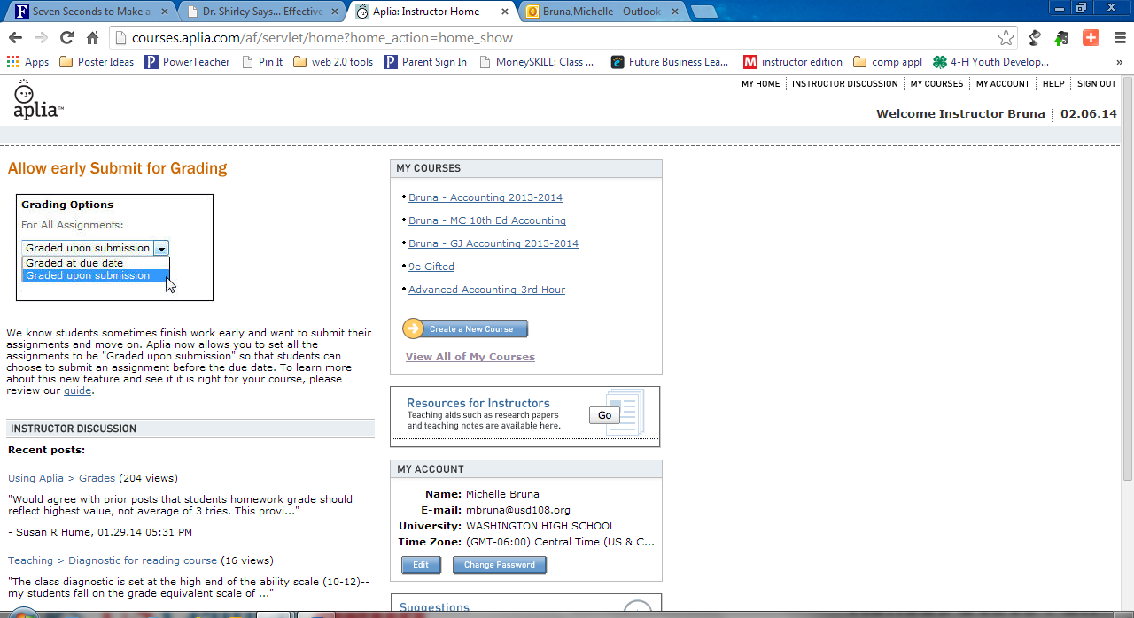

- We will start by clicking on this class, Bruna – MC 10th Ed Accounting or Bruna – GJ Accounting 2014.

Here is where you click and print your course login information.
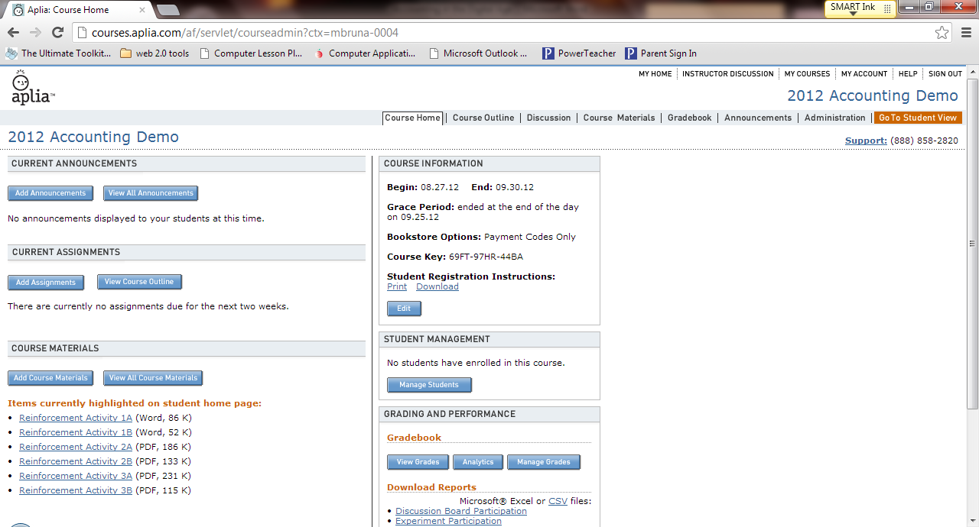

Course Outline
- Click on course outline.
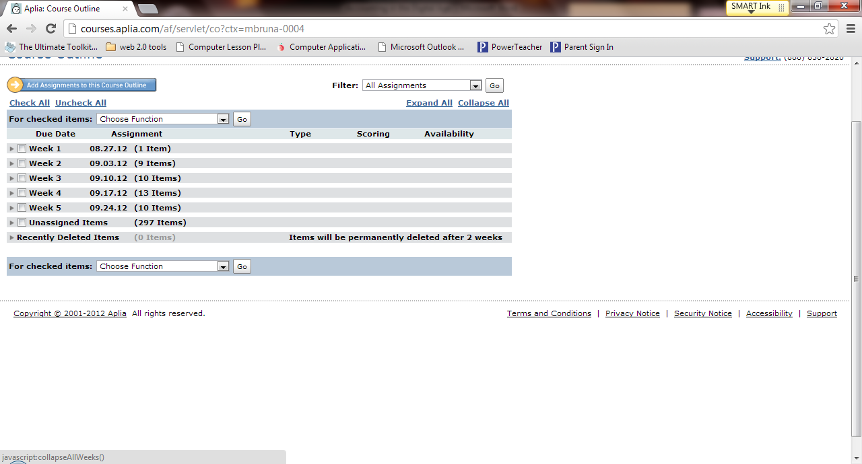
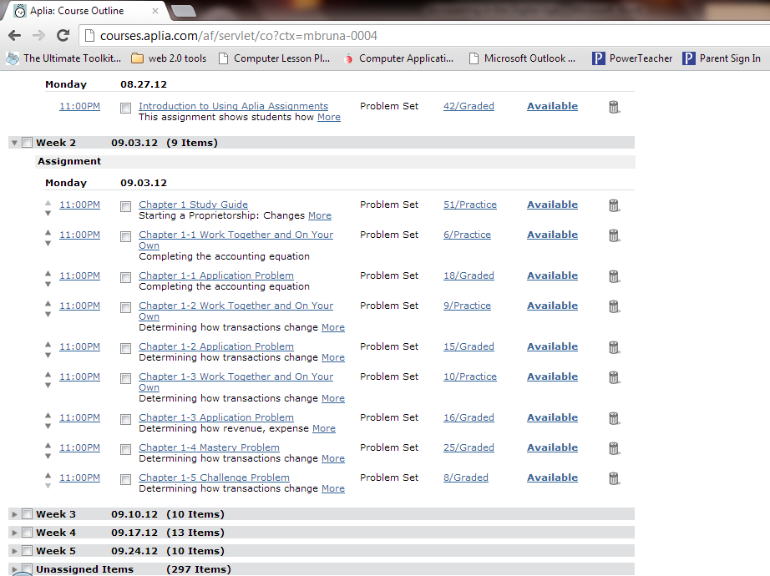
Here in course outline is where you spend the most time. In this screen you assign the problems and tests. The Unassigned Items are where you will find the tests, versions A and B.

We are going to move some assignments around and change from practice to graded.
- First, moving assignments is just clicking on the time next to the assignment.
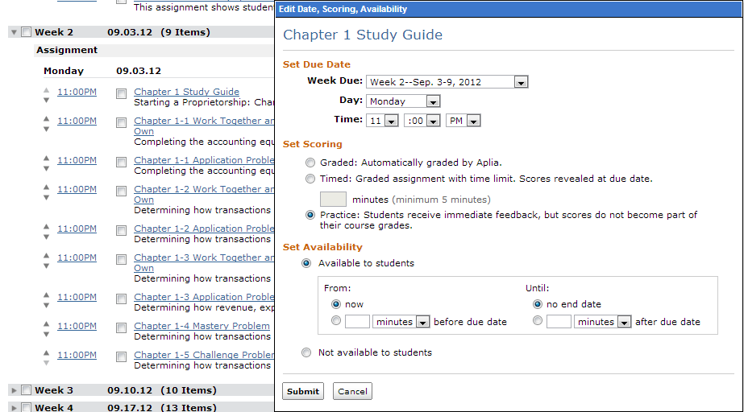
- Next, a new window appears. On this screen you can tell the program which week you want the assignment, the day, and time. (I leave the 11:00pm all the time except for the study guide and test.) You can also choose if it is graded, Timed, or Practice.

- Click Submit when finished making changes.

Where are the Tests?
The tests are to be found in the Unassigned Items located under all the weeks. I move the tests when I set up the assignments for the chapter. This is the time that I use the Set Availability options. Below is an example of one of my tests. The time was changed to 8:30 because all the students were finished with the test and wanted to know how they did.
- Find the test version A for your chapter. Change the information to appear in your week.

Moving a large amount of assignments
Once in a while you need to move all the assignments forward (or back) because of snow days or anything else that can go wrong in a year. I use this fairly often since the program places a chapter per week and it has us finishing before fourth quarter.
- Click the box next to your week.
- At the top of the weeks, click the down arrow for choose function, choose one week later, then click go
- The assignments have been moved.

Teaching the Assignments
As you saw earlier, I worked the problems with you. To work the problems:
- Go to the problem you want to use
- Click on Show Answer to see the answers to the problem.
- Something else, you can click the Aa to make the problem larger (great for projection and smartboards)
- Print button lets you print the problem

Discussion
This is where you can teach the students what it is like to be in an online class. You post a topic and the kids write responses.

Gradebook
Gradebook is the important part of the program that makes our lives as teachers easier. I have exported the grades to Excel but I usually just split the screen with my gradebook program and type in the grades.
In Gradebook, there are 3 different screens: View Grades, Analytics, and Manage Grades. I spend the most time with View Grades.

Analytics allows you to see how a student did on a particular assignment and where the student exactly lost points. Many times a student does one mistake by copying a number wrong in a journal, and that carries to posting and to financial statements.

- Click Analytics
- Click the student
- Click the assignment
- The assignment will appear. The red x’s will mean a wrong answer and a green check mark will be for correct answers.

Manage Grades will allow you to make assignments bonus assignments and drop assignments. I don’t use this section since I have to type all my grades into PowerSchool.

Announcements
I add announcements to say good job on a test.

Writing Your Own Questions
Instead of having the students write the Audit Your Understanding questions out on paper, I add them into Aplia. To write your own questions is not difficult.
- Click on the assignment you want to add question(s) to
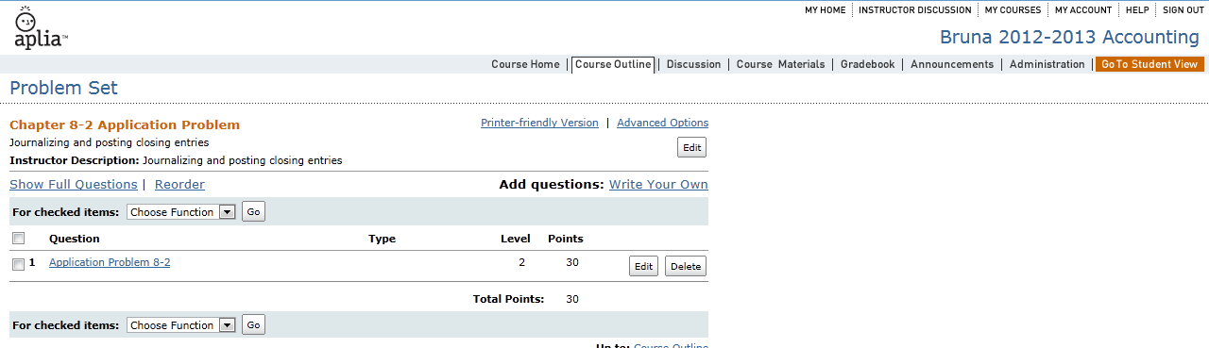
- Click on Write Your Own
- Choose the type of question you want (I use essay for the Audit ?s)
- Fill in the Title (I use Audit Your Understanding Question 1)
- The text box is where you type the question
- Below in the Key Phrase is where you type the answer
- Change the Points Possible if needed
- Below that is the submit button

Administration
This is where I come to grade essay questions I write.
- Administration
- Manage Essays
- Choose the question you want to answer
- I then choose Assign Individual Scores to Essays
- Read the answer and then assign the score
- Click Save and continue

Extending a Due Date
There are times when a student is sick and you need to extend the date the assignment is due for that student.
- Administration
- Adjust under Manual Adjustments
- Pick the assignment then over by Select Action choose Extend Due Date

- Click by the student who needs the adjustment, then Choose Function Extend Due Date and Go

- Select the new date and time and click submit

Videos
Under the My Home page, is New How-To Videos. These videos will help you learn skills. I would look here first, if there is something you want to learn.

