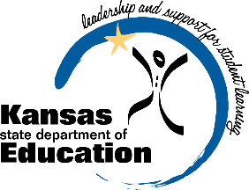
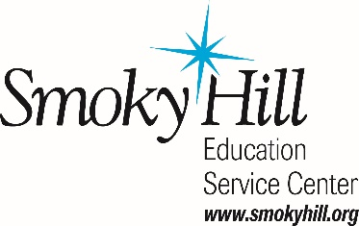
SHIFTING SCHOOL CULTURE RECOGNITION

The Kansas Department of Education and Smoky Hill Education Service Center are recognizing schools and districts that have developed and implemented an SECD initiative for at least one year and are transforming the school/district culture as well as growing student SECD skills. Initiatives can be a curriculum, program, practice, and/or interventions. Initiatives must support at the SECD Standards (Character Development, Personal Development, Social Development) and the Kansas Education Systems Accreditation (KESA) 5R’s (Responsive Culture, Relationships, Relevance, Rigor, Results).

A Promising Practice or Enhanced Spotlight initiative may not be used for this application.
This initiative must be ongoing and implemented for at least one full year before submitting this application.

Was this initiative implemented in an individual school or district wide? _______________________________
Student enrollment in your school or district: ____________________________________________________
Percentage or number of students participating in this initiative: _____________________________________
Grade levels targeted: _______________________________________________________________________
% of student population in the school or district that is eligible for free or reduced lunch: _________________

- Identify the SECD Standard(s) your school is currently supporting through your initiative.
Character Development Personal Development Social Development

- Identify the theme(s) in the 5R’s Framework that this initiative supports.
Responsive Culture Relationships Relevance Rigor Results

- What is your district KESA goal(s) and how does this initiative support that goal?

- Describe your initiative in 2500 words or less. Include how and why the initiative was developed and the frequency of engagement with students. Attach an additional page(s) with the description including your name and school.

- How long has this initiative been implemented, include starting date?

- What tools were used to measure the effectiveness of this initiative? What were your results?

- How is the initiative affecting the climate and culture of the whole school?

- Was there any community involvement and how were they involved, include frequency of engagement? Did you measure or evaluate community response or satisfaction?

Contact Name and Position: __________________________________________________________________________
Email Address: _____________________________________ Phone: _______________________________________
School: ___________________________________________ USD Name & #: ________________________________
Mailing Address: ___________________________________ City: ___________________ Zip Code: ___________

Principal or Superintendent Signature: ________________________________________________________

Email your application to Noalee McDonald-Augustine at nmcdonald@smokyhill.org.
The Application Fee is $25. Make checks payable to Smoky Hill Education Service Center –
605 E. Crawford - Salina, KS 67401.
Deadline for submission is March 22, 2019.

