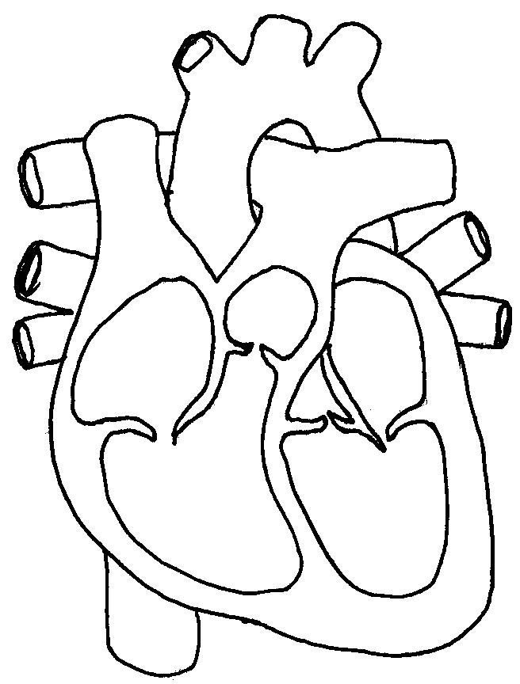

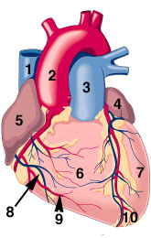

How is electrophoresis performed? | 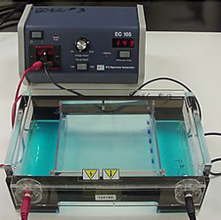
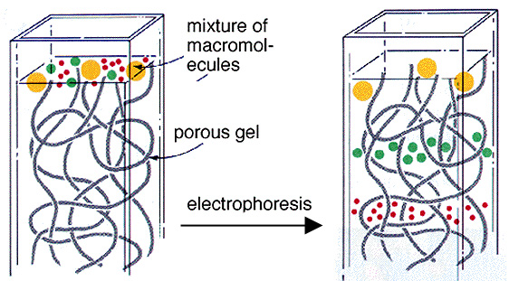 | How does the DNA separate?
How is the final gel read and interpreted? | 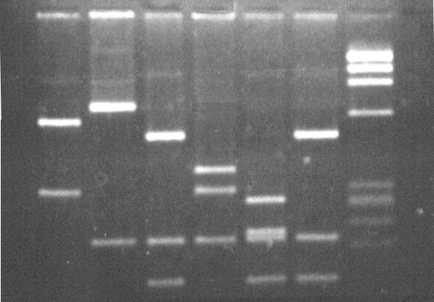

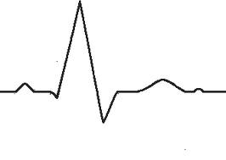

Other Items for Study Guide
Heart Rate and Blood Pressure
Veins, Arteries and Capillaries
Cholesterol HDL, LDL, Triglycerides

